My Word
First and foremost, I’m listening and acting to you, my clients. This course, the manual contents, and the handouts are the result of my client’s feedback and recommendations – I’m merely the vehicle to produce this for you. Clients have suggested items, such as the shortcuts handout, and I am blessed to provide this to you. Clients have said, “Make the steps easier to read,” and many, many other great comments. Please if you have any constructive feedback or recommendations let me know at greg@gregcreech.com. Thank you and now on to your course!
The full title of this course is “2007 My Word, Your Word, It’s Word!” Word is a tremendous application and is much more than a Word processor, although processing words is its strength. When Word gives me problems (and it will), I remember when I had to use correction fluid by the gallon sizes because I did not have a delete key or undo icon. The days of correction tape and film and the typewriter are pretty much over for typing documents.
In this course we will examine Word and its applications in detail. We will begin with the basics and go to the advanced levels of word. We will use real documents and I encourage you to develop your own. We will customize Word to fit your needs and learn a lot of neat tips. Here’s the outline of our Word class.
First, we will look at Word as a processor of words and information. We will examine letters and memos. Using Word as a Word Processor is our first part. We’ll learn some of the features that are used across the Office Suite such as Command Buttons and The Ribbon customization and Copy/Paste.
We will learn to navigate in Word, use many of its efficiencies, and manipulate various types of documents. We will learn some of the important and popular tools of Word, such as Tables and Mail Merge. We will study Word’s graphic abilities with photos, auto shapes, diagrams, and other eye catching elements. We will use Word to organize a manual and understand how Word is used for large documents.
Here are some of the items we will learn:
Text and Character Formatting,
Special Paragraphs and Indents,
Using Bullets and Numbering,
Working with graphics and photos,
Create Table of Contents and Mail Merge,
And a whole lot of other neat stuff.

Thank you and enjoy the Your Word.
Word as A Word Processor
Getting to know your Interface: Ribbon and Commands
Open Word. Word will open with a blank document, ready for you to begin typing. You may open an existing document or begin creating a new document. We will create a new document. Since this a course on Word and not on how to type or enter information, we will use existing documents, too.
Let’s become accustomed to our 2007 Office Ribbon and items in the user interface for Word. Like all of my manuals, Word produced this document (with a little help from me); it even did some of the typing. Let’s get started right away.

Write your notes here:_________________________________________________________

________________________________________________________________________

________________________________________________________________________

________________________________________________________________________
The New Interface
One of the best new features of Office 2007 is the new user interface including the Quick Access Toolbar, Tabs, and Ribbon. Microsoft calls this type of interface a results-oriented interface and I must agree – you truly will get to your desired results, effects, and functionality with less time and minimized frustrations – for the most part. Without a doubt using the new Office Suite and 2007 Word will increase your productivity and make getting to functions much easier and with fewer clicks and less frustration. The Home Tab in Word 2007 is pictured below with the Quick Access Toolbar at the top of the screen and the Home Tab’s Command Buttons displayed.
Besides the increase functionality using the tabs and ribbon, there is new power in using the shortcut menus with “right clicking” or using the secondary mouse button. When you “right click” or use your secondary mouse button you still receive the Shortcut menu including some of your favorite commands, such as copy and paste. Also you receive a Mini Toolbar containing favorite icons to use such as font, bold, the format painter and other often used icons. This is another time saving feature for applying formatting to selected areas of your document.
A Hot Tip! The Mini Toolbar appears when you select text and move your cursor up; you’ll notice how the Mini Toolbar fades in and fades out as you move your mouse up and down.
There is the scrolling Zoom in the status bar that changes your view as you scroll through your percentages. A picture of the new scrolling zoom is at right and allows you to see your changes in “real time” rather than guessing the percentage you need.
Word 2007 offers a preview of your formatting, too, such as when you select your text and scroll through the fonts or font size the application will show you the effect changes before you make your final click or selection. This feature is called Live Preview.
We will examine these new user interface features, and we will look at common features across Office 2007, such as the new Office File Button and the Quick Access toolbar. Now, let’s get more familiar with these interface objects.
The Microsoft Office Button
The New Microsoft Office Button at the upper left corner of your screen allows you to quickly and easily Save, Print, and perform other important actions on our Word files. When clicked the Microsoft Office Button produces the menu at right. From here you can access important items quicker and easier than you’ve accomplished in previous versions of Office. With the Save as cascading menu, you can quickly save your document or other file in PDF, XPS, or previous versions of the application. The Microsoft Office Button is in all of the applications that use the interface (Word, Excel, PowerPoint, and Access) and changes little from each of the applications.
With a Word Document open, Click the Microsoft Office button and click New.
A screen appears for you to choose a blank document or use one of the templates.
Double Click the Blank Document item or Click the Create button
Another important item on the Office button’s menu is the Options button, depending upon your application the button will read Word Options, Excel Options, PowerPoint Options, etc. We will use the Word Options button later in our course.
A Hot Tip! The Recent Documents pane displays the files you have recently opened (up to 50). Notice the Push Pin in the recent documents pane. If you click the pin, it will activate or pin the file and this document will always be on your recent document list regardless of when and how many times you have opened this document. You can “unpin” or deselect the pin by clicking it again.
Quick! Access the Toolbar
For years and years we have used many toolbars in the Office Suite, gone are all of the toolbars, and they are replaced with the tabs, ribbons, and pop-up dialogues boxes and task panes. We still have one toolbar available for us to put our favorite commands. The Quick Access Toolbar appears at the top your screen and pictured here.
This has the Save, the (Very Popular) Undo, and Repeat command buttons on it. You can customize the Quick Access Toolbar easily. We’ll add some of my often used icons and actions to the toolbar – I encourage you to play around and add your own favorite icons.
Here’s how to customize the Quick Access Toolbar.
Click on the Drop Down arrow at the end of the toolbar and in the cascading menu choose some of your often used items, such as Quick Print and Print Preview. Clicking these items adds them to your Quick Access Toolbar.
To add other favorite command buttons click the More Commands … item
The Customize screen appears pictured at right.
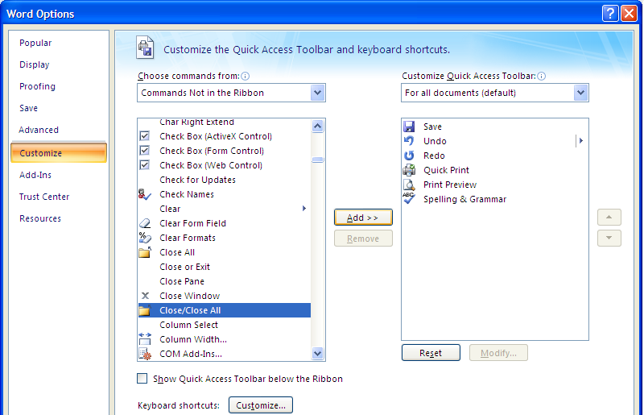
From the Choose Command from section choose Commands Not in the Ribbon from the drop down list and notice all of the different areas from which you may choose a command.
Scroll down Click the Close/Close All command to select it.
Click the Add button to add it to your toolbar.
If you want to move the icon, select it and click the up or down arrows at the right of the icons for your toolbar. This will move your selected icon up or down on your toolbar.
Next change the Choose command from box using the drop down list to Home Tab.
Add the Change Case icon – this will provide a list for you to use Uppercase, Sentence, and other types of case format.
Continue to add some of your favorite commands to the toolbar.
Once complete, click the OK button at the bottom of your screen.
A Hot Tip! Notice the small i symbol on the Choose commands from text – this will provide a short cut for you. This tells us that we can an icon from our ribbon to our Quick Access Toolbar by right-clicking the icon. Let’s try it out.

With the Home Tab’s Icons visible Right-click on one of your favorite icons – I’ll right click the Show/Hide icon.
From the menu choose Add to Quick Access Toolbar.
The icon displays on your toolbar.
The shortcut menu provides other Quick Access Options, too.

A Hot Tip! You may add an entire group to your Quick Access Toolbar, too. Simply right click on the Group, such as the Paragraph group on the Home Tab, and from the short cut menu, click “Add to Quick Access Toolbar”. The Group’s command button appears on your toolbar and when clicked displays all of the command buttons associated with that group.

You’ll have to open the customize screen to move your icon to a different location.

As you use 2007 Word, you’ll discover icons that you will want available all of the time. Unlike the previous versions of Office with toolbars your Home, Insert, Page Layout and other tabs change your icons; therefore, to have an icon constantly available without clicking a tab or right clicking, you’ll have to add it to your Quick Access Toolbar or assign your command to a keyboard shortcut or use one already defined for you such as the ever popular CTRL + C for copy.
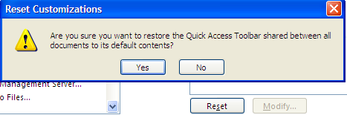
If you mess up your toolbar and want to put it back to the way the toolbar came from the Microsoft Factory or it’s original sate, in the Customization screen you can click the Reset button and Office provides this message. If you click the Yes button, all of your customization disappears for you to start fresh adding your command buttons.
Productive Ribbon, but
Where are the Bows?
Microsoft’s Word 2007 Ribbon is productive, beautiful, and combines our previous toolbars, menus, and task pane features in a much easier and a more powerful way of working with the applications. You are going to find the Ribbon a bit confusing at first and the feature of Live Format Preview, that displays your selected text’s new format based on hovering your cursor over a style, font, or size “freaked” me out at first. However, once I worked with the new Ribbon and features that pop out of nowhere or are enhanced greatly, such as the Shortcut Toolbar that appears with your Shortcut Menu when you right-click, I like using these features and find them helpful. Here’s why and how, but first two new shortcuts you’ll want to know.
Two important and time saving Hot Tips for you in using the Ribbon and Tabs!
Hot Tip 1: First, the Ribbon takes up a lot of space on your screen. You may minimize the Ribbon and use it only when you click on a tab. To minimize the Ribbon double click the active Tab’s Name OR click the quick Access’ Customize arrow and click the Minimize the Ribbon item as displayed at right. The Ribbon will minimize to tabs. To use a tab, you click the tab and the Ribbon’s tab expands for you to use the Command Buttons. When you click back into the body of your document, worksheet, or presentation the Ribbon minimizes again. This is similar to using the old Menu bar. You may turn this feature off by double clicking the Tab’s Name OR activating the Customize Quick Access Toolbar menu and unchecking the Minimize the Ribbon item.
Hot Tip 2: Second, if you have scroll button on your mouse and the Ribbon is NOT minimized, you may scroll to the different tabs rather than clicking the tab. Moving your cursor to the Ribbon and rolling your scrolling button up or down changes the tabs for you!
An Important Gotcha! With the Ribbon minimized you cannot scroll through the Tabs as described above. You’ll have to maximize the ribbon in order to scroll through your tabs and command items.
Try these two shortcuts, I think you’ll like using these two features in Word 2007.
Tab Exercise
Item Description Amount Salesperson
1332 Phone $35.00 Smith
1333 Computer $1250.00 Jones
1334 Desk $750.15 Smith
1335 Chair $220.00 Jones
1336 Monitor $399.99 Ramsey
1337 Lamp $14.50 Smith

